Associate Exit Flow

*(Associate Exit Flow – Guide)*

This document describes in detail the **Associate Exit Flow**. This portal has different user roles like (*Associate, Program Manager, HRM- Human Resource Manager, HRA, Team Lead, Manager-IT department, Manager-Admin department, Manager-Finance department, Manager-Training department).*

**Associate:**

1. The associate is required to Login to the portal (Via single sign-on) with SenecaGlobal email Id. After authentication, the associate is redirected to the Dashboard page. The associate needs to click on the **Associate Exit** section, and then **Resignation module**.

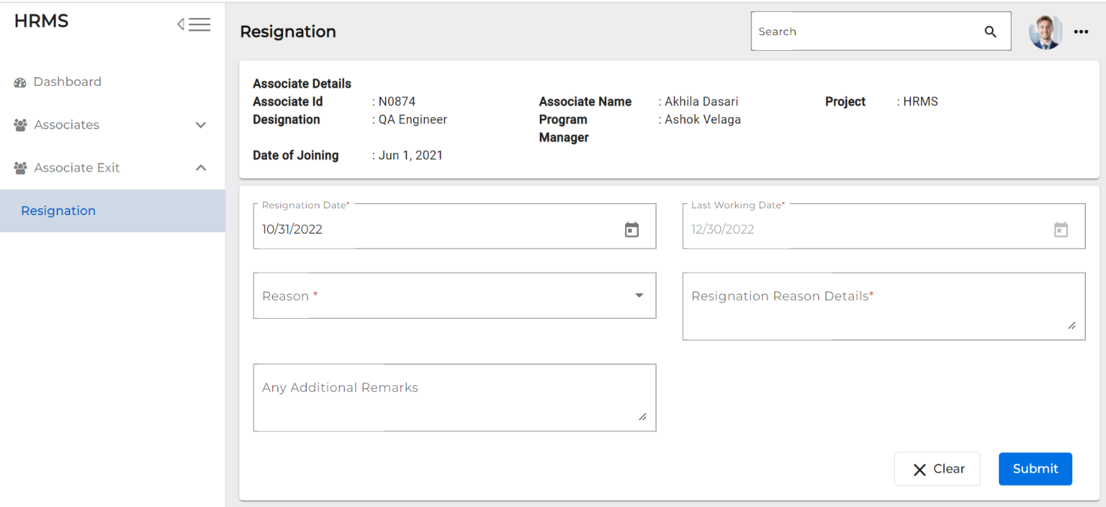

1. The ‘**Reason’** and ‘**Resignation Reason Detail’** fields are mandatory to be filled.
2. The associate needs to enter the resignation details and click on ‘**Submit’** button.

**The Team Lead, Program Manager and HRM leader are notified, and the status is changed to 'Resignation Submitted'.**

**Revoke by Associate**

This option will be viewed after associate submitted his/her resignation on associate Dashboard.

1. Associate needs to login to the portal (Via single sign-on) with SenecaGlobal email Id. After authentication, associate will be redirected to the Dashboard page. Associate can view the revoke button.

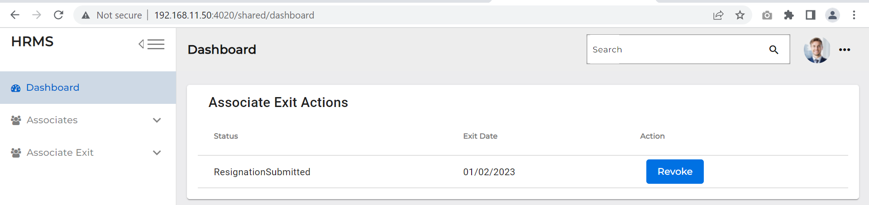

1. The Associate can Revoke the resignation by giving suitable reason.
2. Click on Revoke
3. Give Revoke Reason
4. Click on Submit
5. After submitting the revoke on associate dashboard, revoke button becomes disabled and status changes to ‘**Revoke initiated.’**

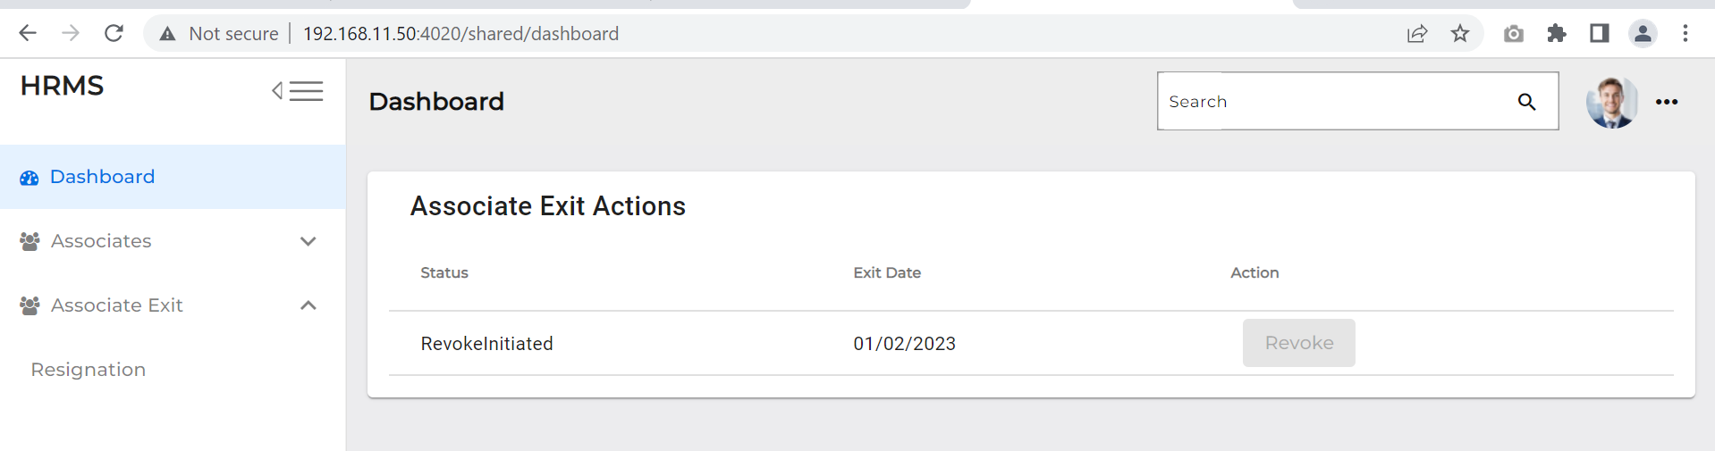

**After submitting the Revoke, an Email is triggered to the Program manager, HRM, Team lead and Associate; then the status is changed to ‘Revoke initiated.’**

**Associate (KT)**

Once Team lead submits the KT plan. Associate can view the Transition plan action Button

1. Associate needs to login into the portal (Via single sign-on) with SenecaGlobal email Id. After authentication, associate will be redirected to the Dashboard page. Associate can now view the Transition plan button.

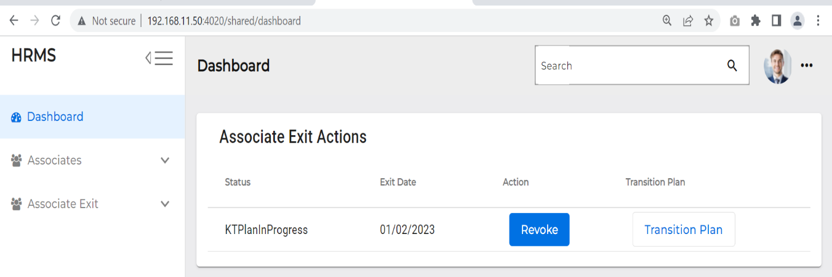

1. When the Transition plan button is clicked, it is redirected to the ‘Knowledge Transfer Handover Takeover’ screen.

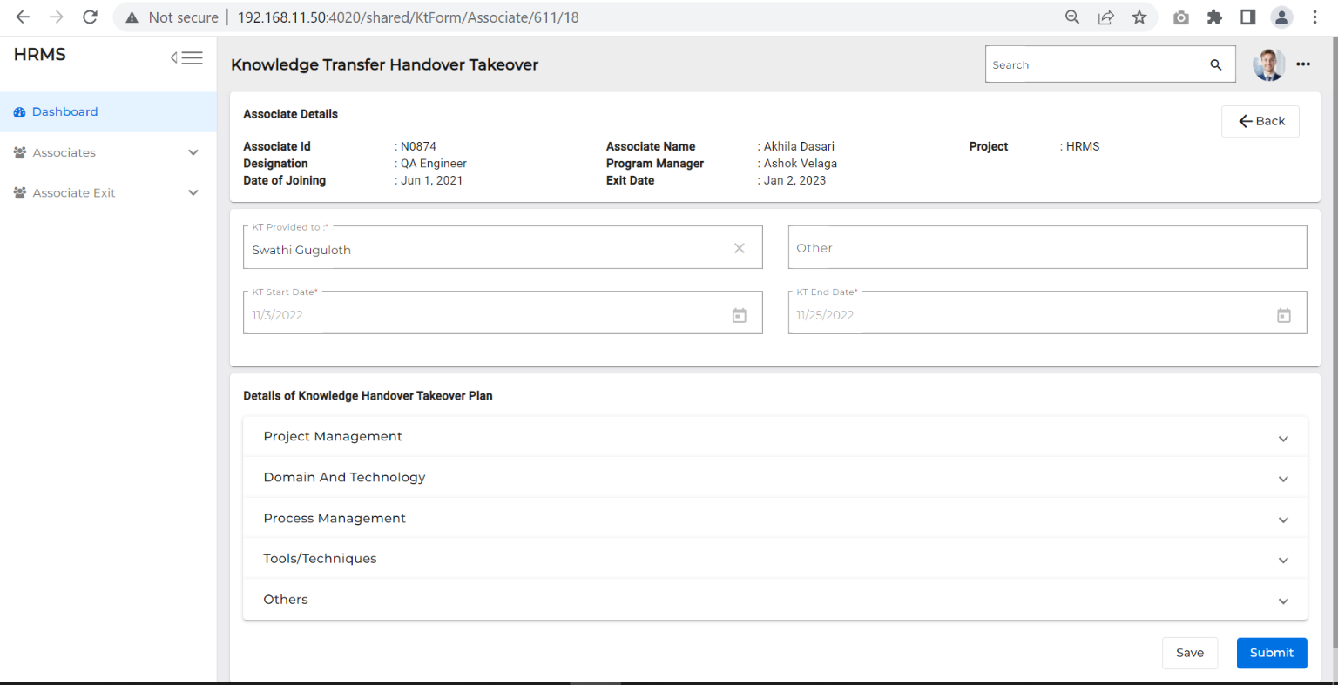

1. Other fields are ‘Read only’ mode, except – the Details of Knowledge handover Take cover plan status field.
2. System displays all the tasks that need to be completed before the last working date.
3. Associate should change the status as ‘Completed’ in the Knowledge handover Takeover Plan.
4. Clicking on ‘Submit’ changes the status to Resignation in Progress.

* **An Email is triggered to the Team Lead, the KT provided associate, Program Manager and the status is changed to ‘Resignation In progress’**